**CK Metrics**

**CK Metrics Suite**

**Five Projects links**

**Spring Boot:** [**https://github.com/spring-projects/spring-boot**](https://github.com/spring-projects/spring-boot)

**Portfolio:** [**https://github.com/portfolio-performance/portfolio/tree/master**](https://github.com/portfolio-performance/portfolio/tree/master)

**Jdbi:** [**https://github.com/jdbi/jdbi**](https://github.com/jdbi/jdbi)

**Selenide:** [**https://github.com/selenide/selenide**](https://github.com/selenide/selenide)

**reactor-netty:** [**https://github.com/reactor/reactor-netty/tree/main**](https://github.com/reactor/reactor-netty/tree/main)

**Objective**

The objective of this project is to find the CK Metrics Suite for five projects from GitHub.

**Data Set**

**Spring Boot**

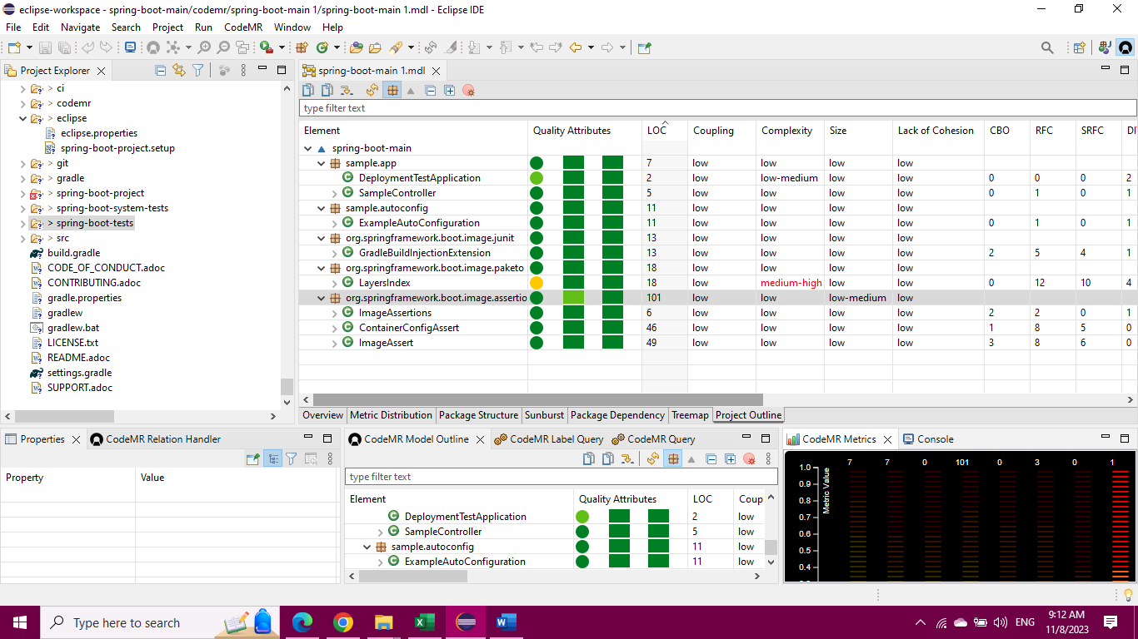

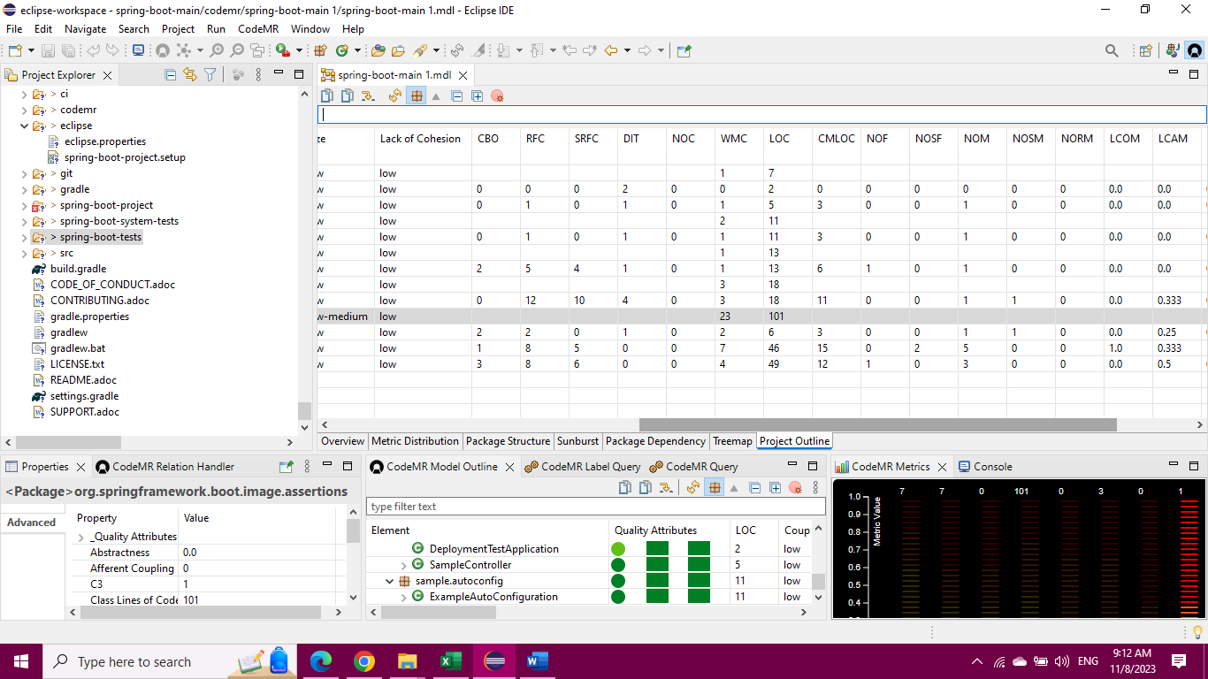

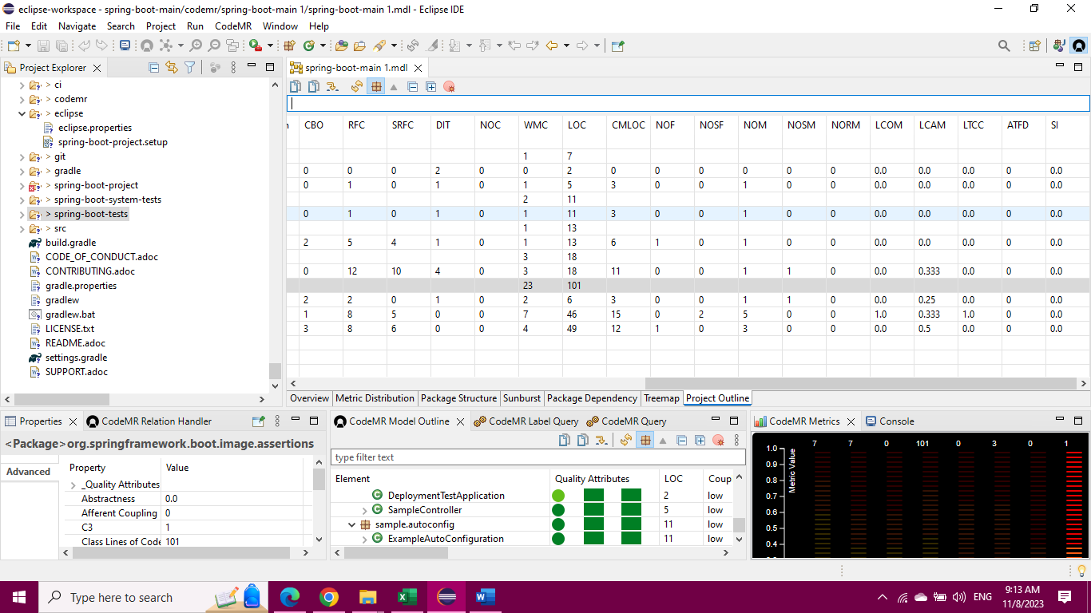

**Portfolio**

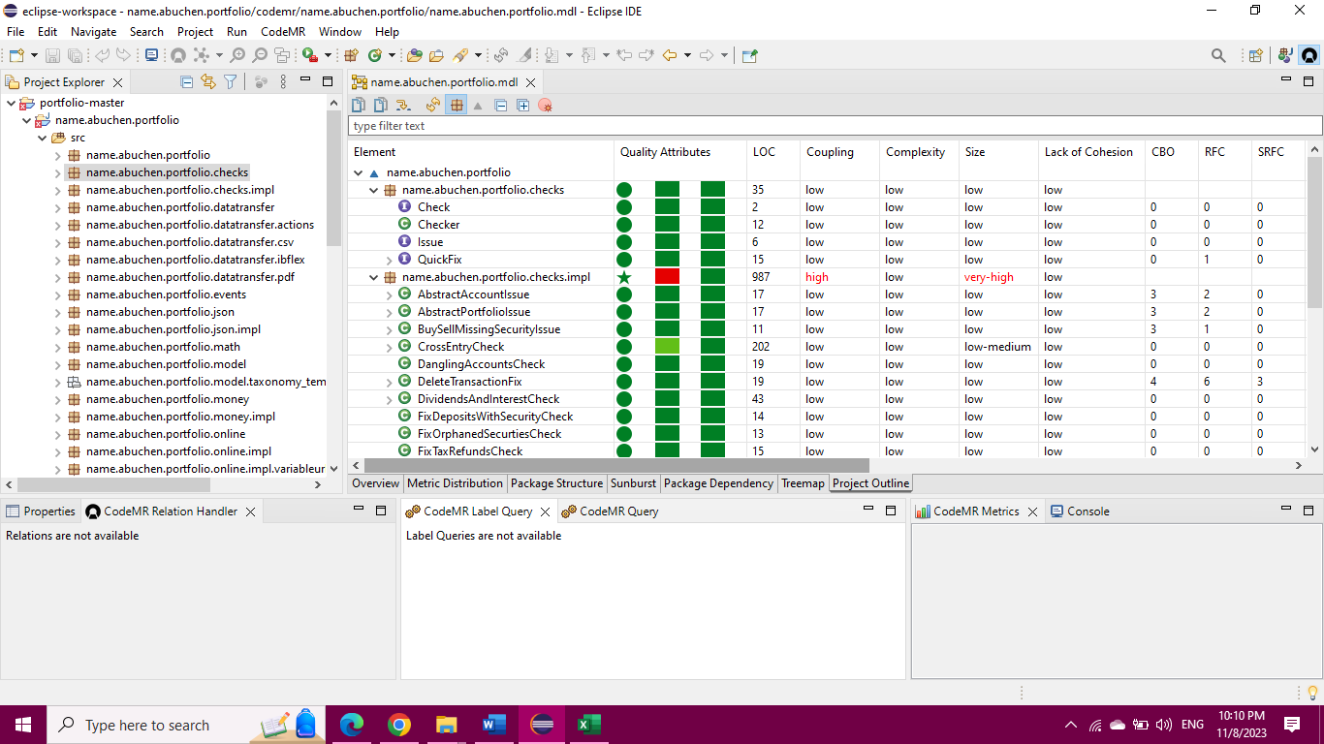

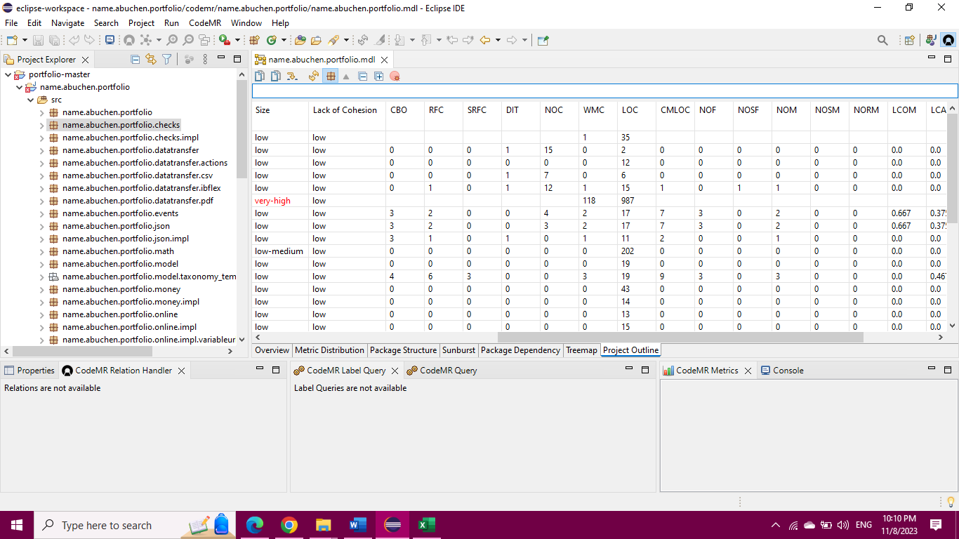

**Jdbi**

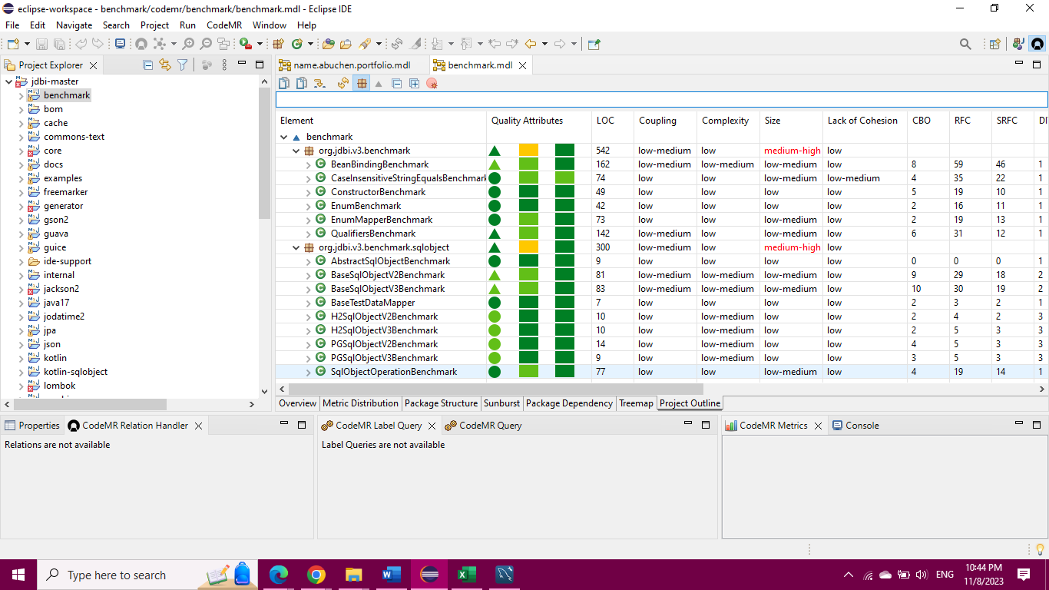

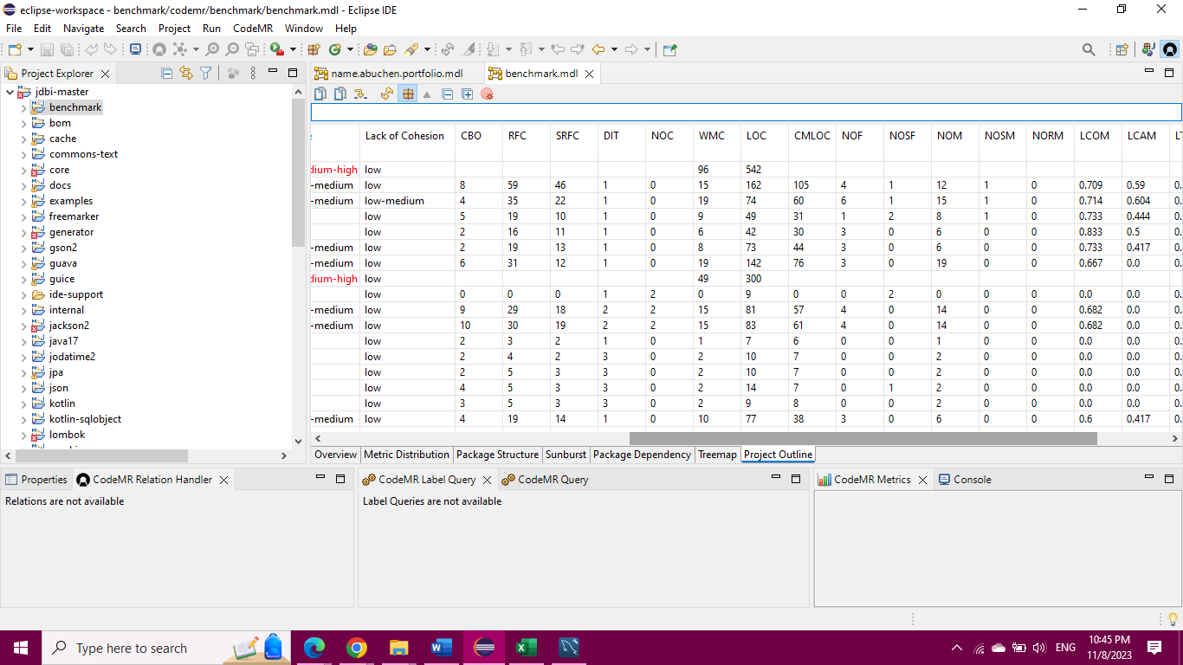

**Selenide**

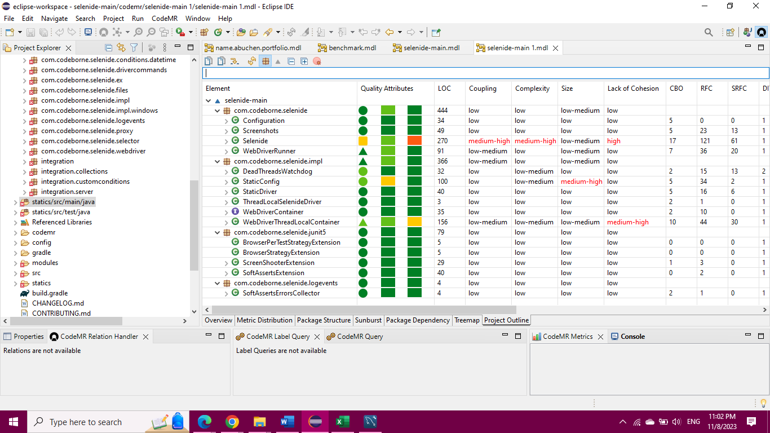

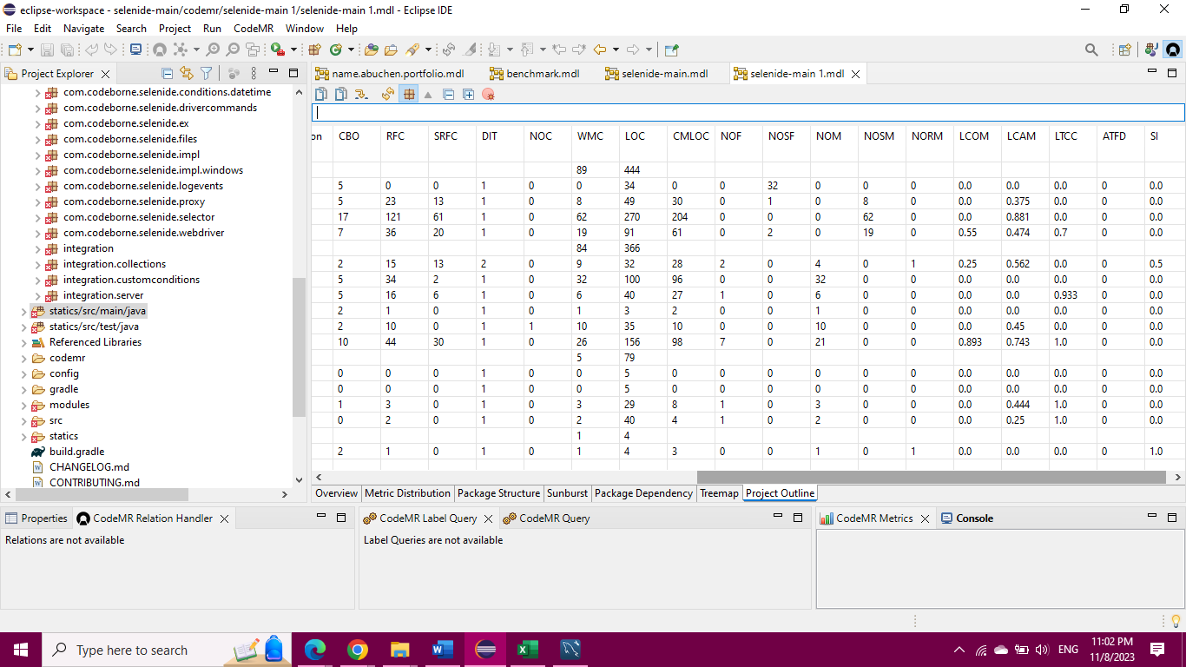

**Reactor-netty**

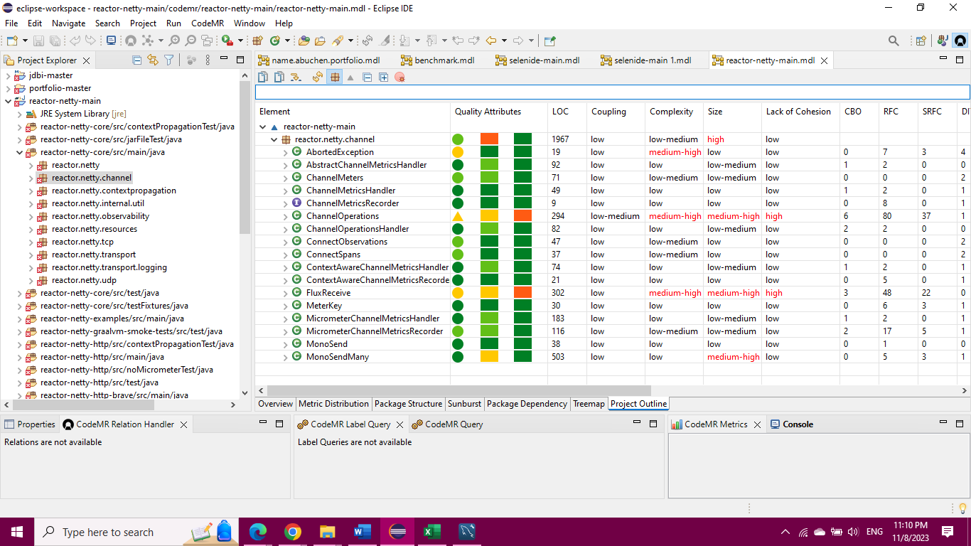

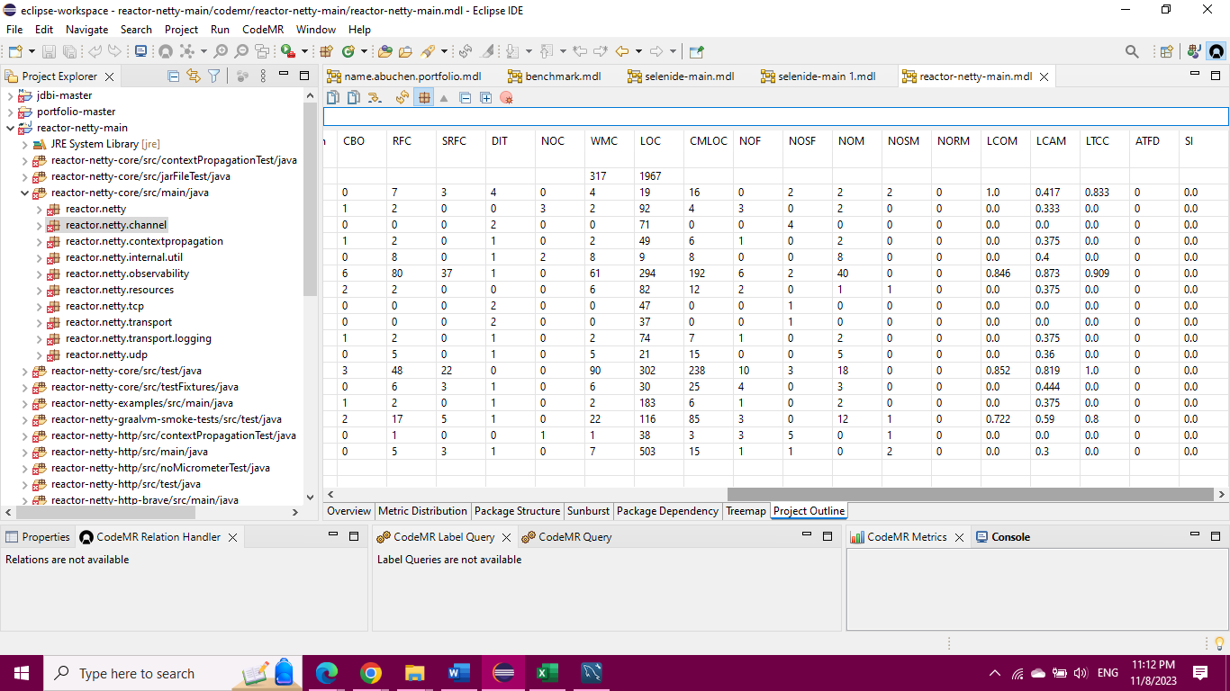

1. Weighted Methods per Class (WMC): Indicates the effort required to implement and test a class based on the number of methods and their complexity.
2. Depth of Inheritance Tree (DIT): Measures the maximum length from a node to the root of the inheritance tree, reflecting the complexity of object-oriented design.
3. Number of Children (NOC): Represents the immediate subclasses under a class, influencing reuse and abstraction.
4. Coupling Between Object Classes (CBO): Assesses the level of coupling between classes, which affects modification and testing complexity.
5. Response for a Class (RFC): Quantifies the methods potentially executed in response to a received message, impacting testing effort.
6. Lack of Cohesion in Methods (LCOM): Evaluates the dissimilarity of methods in a class by their access to instance variables, with higher values indicating lower cohesion.

**Tools**

**Eclipse IDE**:

* + **Integrated Development Environment (IDE)**: Eclipse is a widely used open-source IDE primarily used for Java development, but it supports multiple programming languages through plugins. It provides a comprehensive set of tools for coding, debugging, and testing software.
  + **Features**: Eclipse offers features like code completion, syntax highlighting, debugging tools, version control integration, and a wide range of plugins for various programming languages and frameworks.
  + **Platform**: Eclipse is a cross-platform IDE, meaning it can run on multiple operating systems such as Windows, macOS, and Linux.
  + **Community and Support**: It has a large and active community, which means there are many online resources, forums, and tutorials available for help and support.

**CodeMR**:

* + **Code Quality Analysis Tool**: CodeMR is a tool that provides static code analysis for various programming languages, including Java, Scala, and Erlang. It helps developers analyze code for potential issues, maintainability, and other metrics.
  + **Features**: CodeMR typically offers features like code complexity analysis, dependency analysis, code smell detection, and other metrics that help developers maintain high-quality code.
  + **Purpose**: The primary purpose of CodeMR is to assist in improving the quality and maintainability of codebases.
  + **Integration**: It can often be integrated with IDEs and continuous integration tools to provide real-time feedback on code quality during development.
  + **Usage**: CodeMR is particularly useful for large and complex codebases, where maintaining code quality and structure can be challenging.

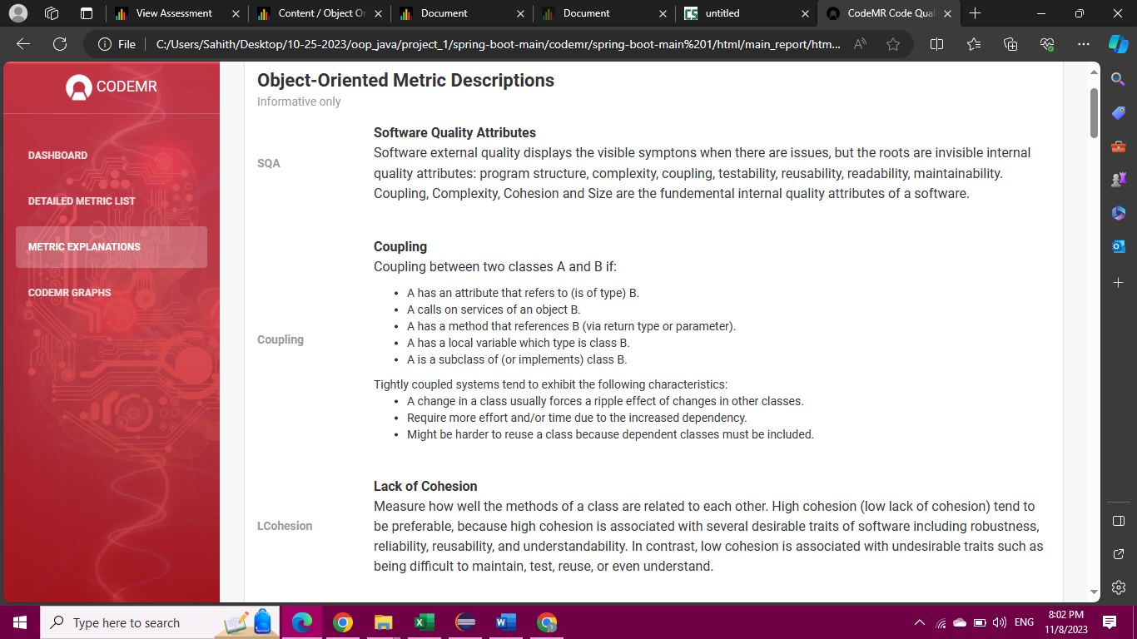

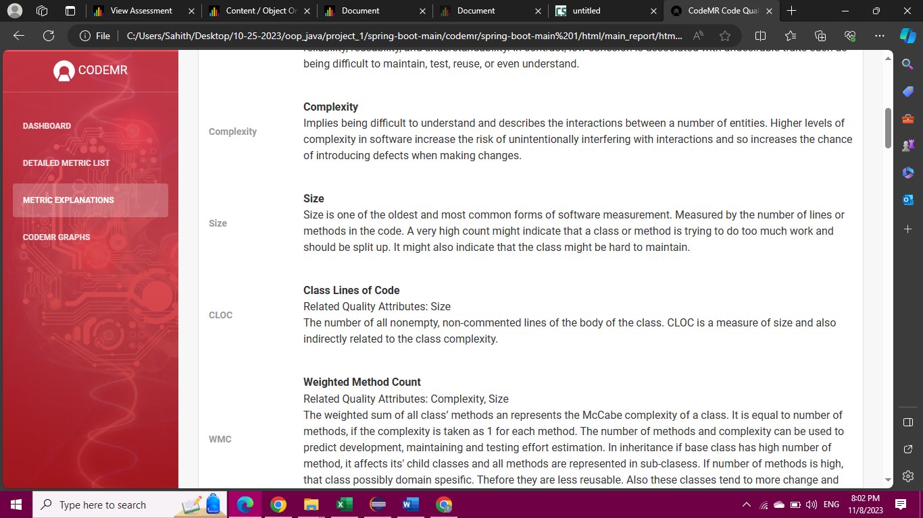



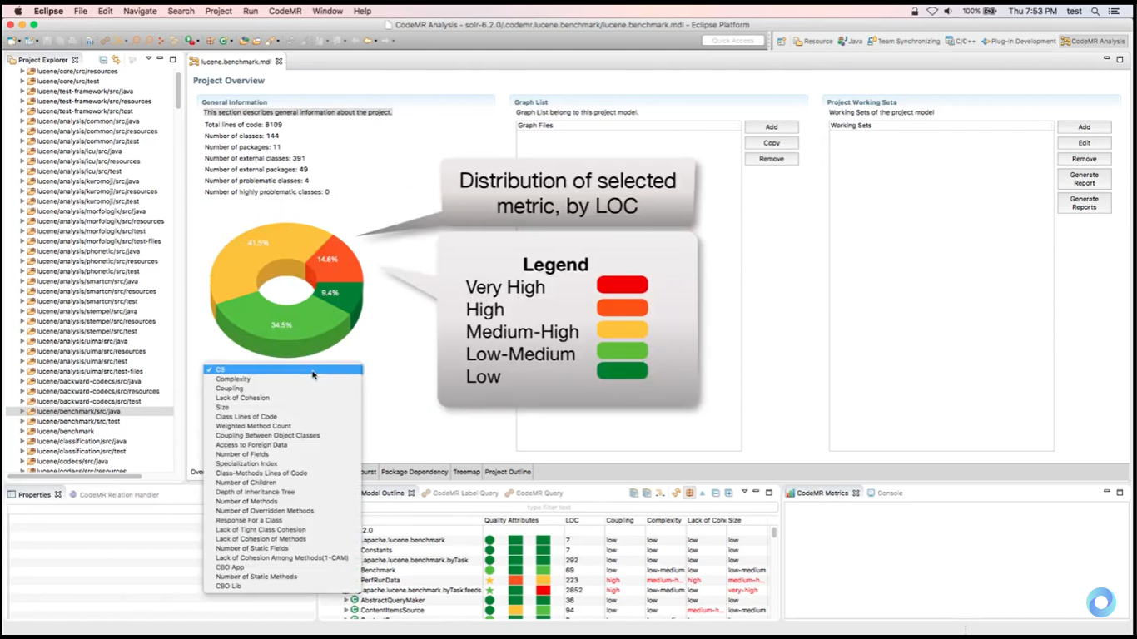

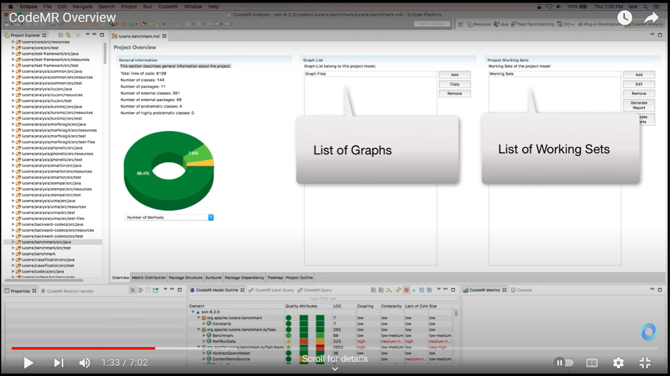

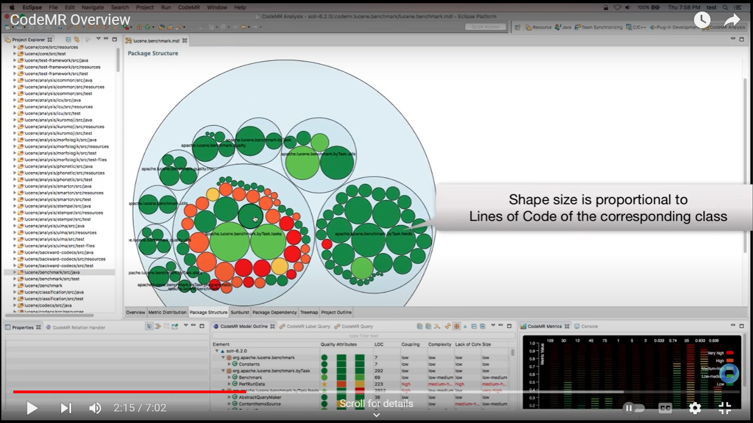

**Graphs**

**Spring Boot**

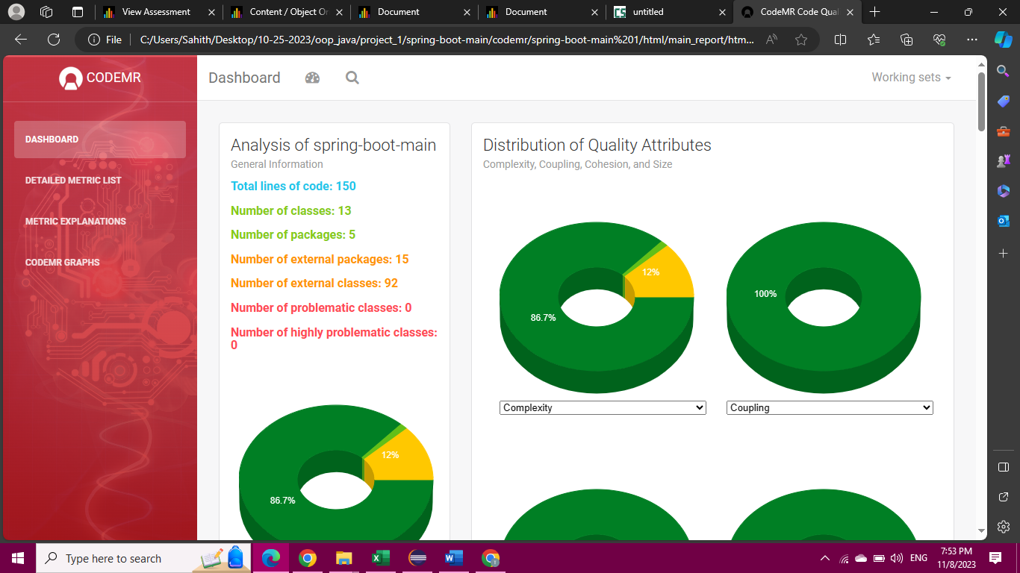

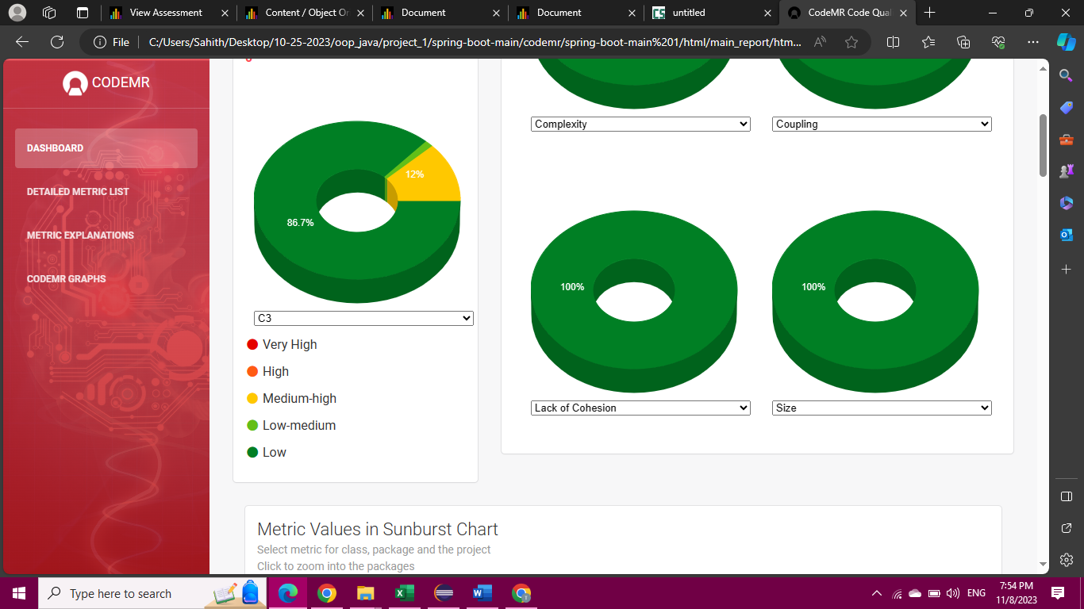

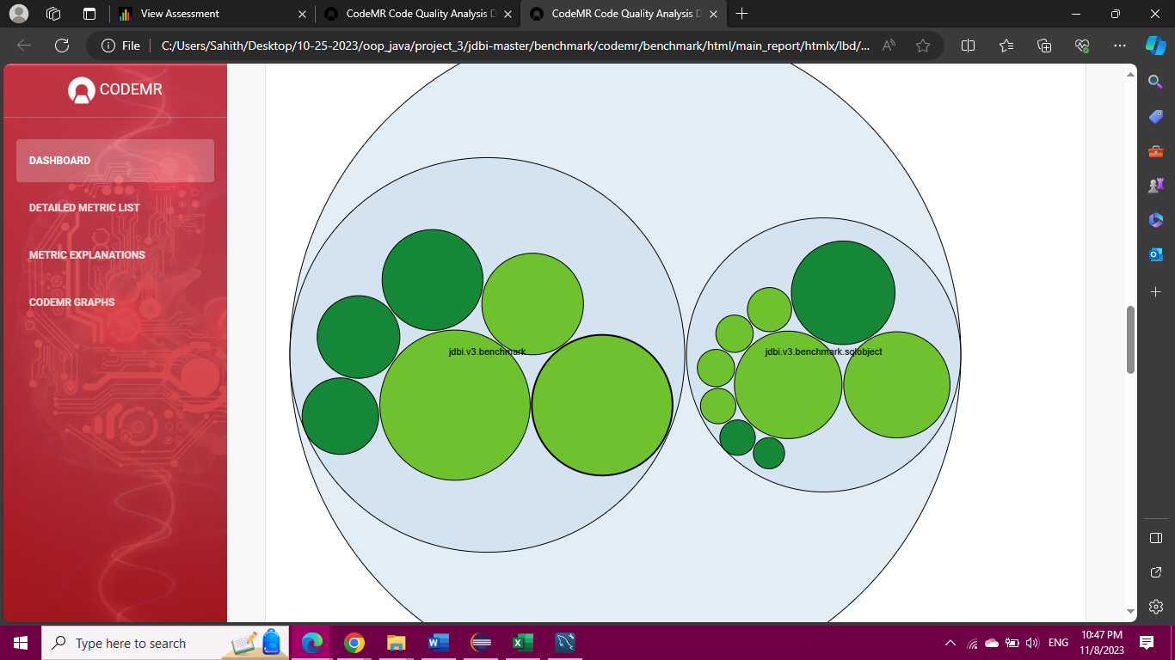

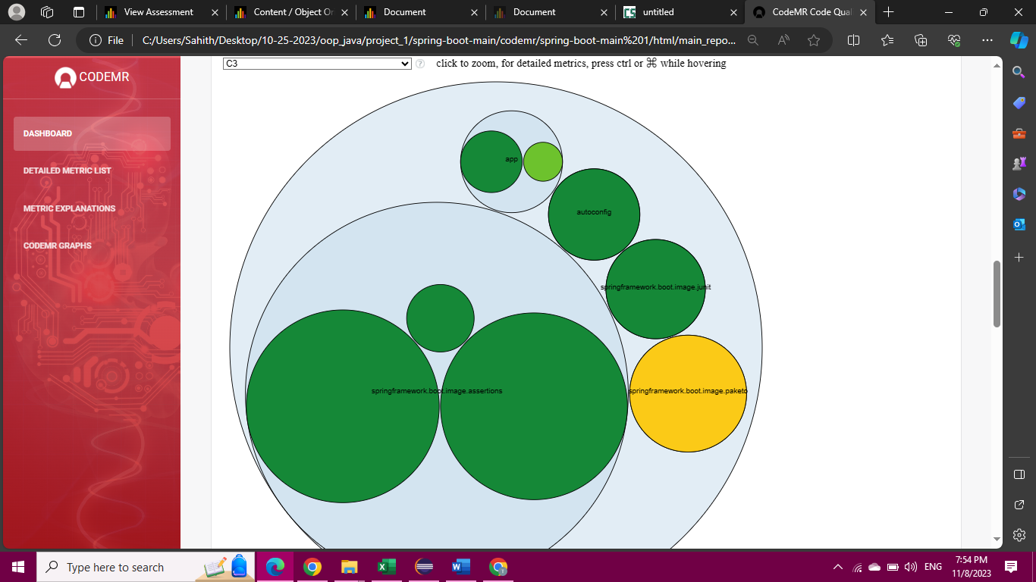

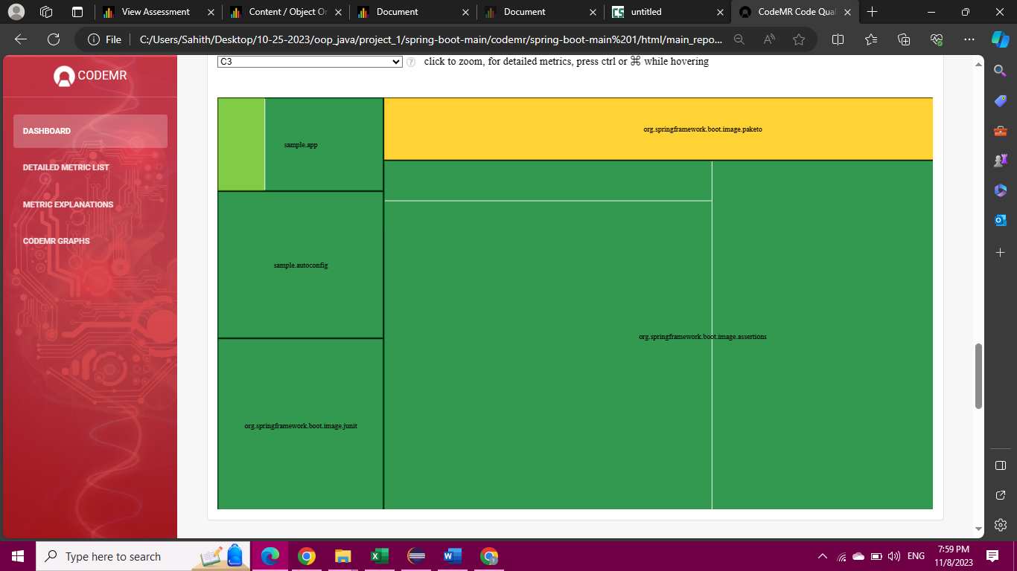

**Portfolio Application**

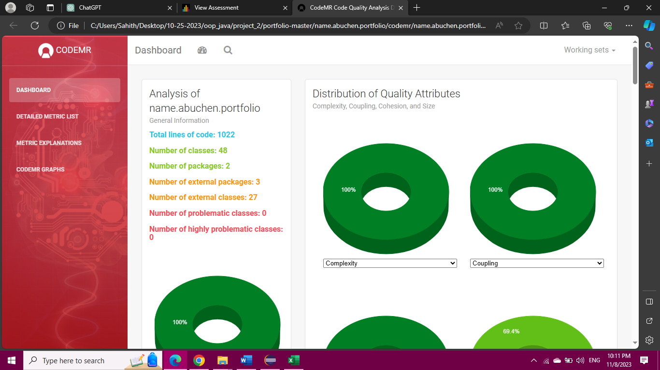

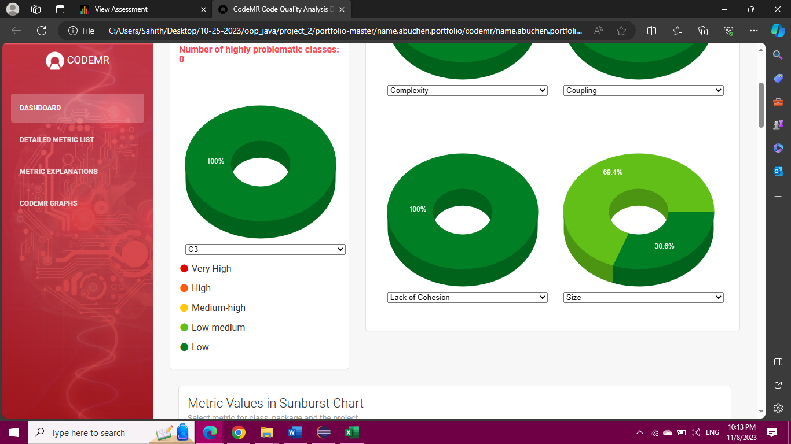

**Jdbi Application**

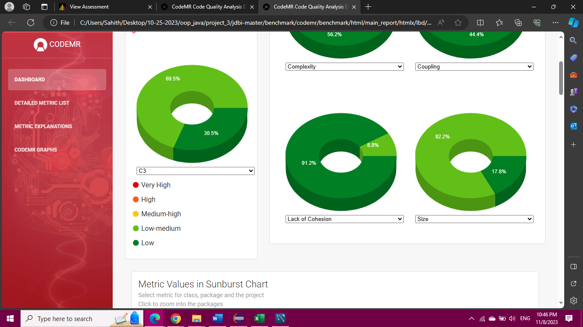

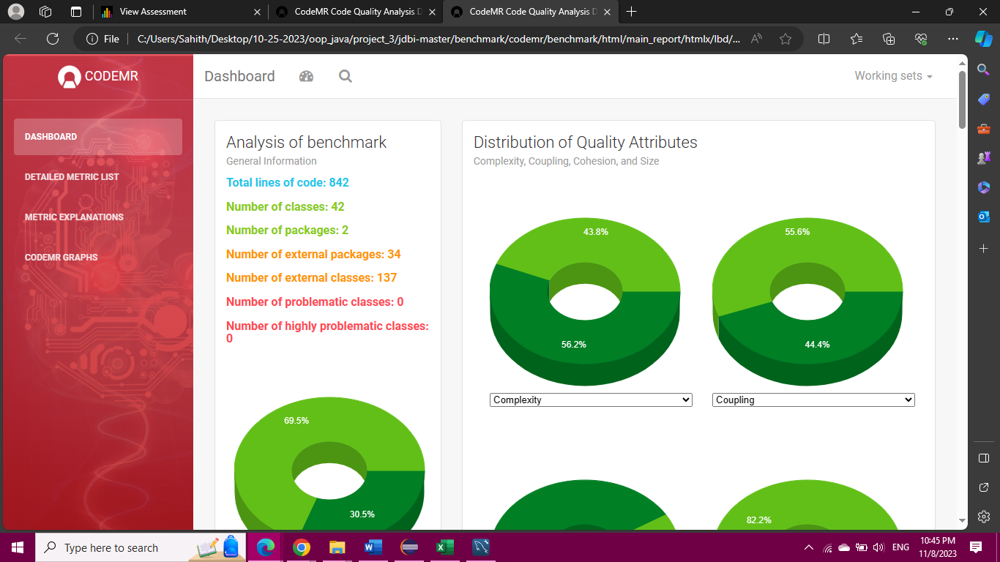

**Selenide**

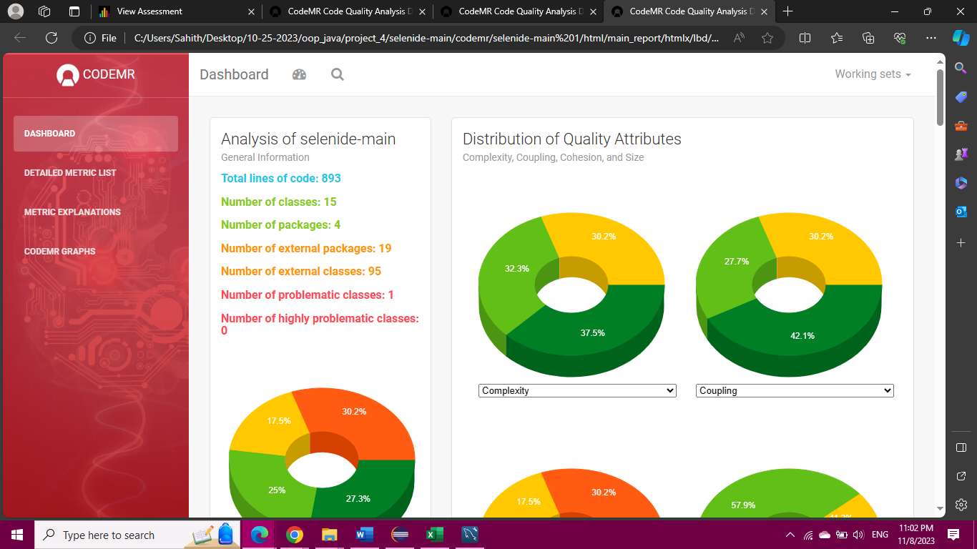

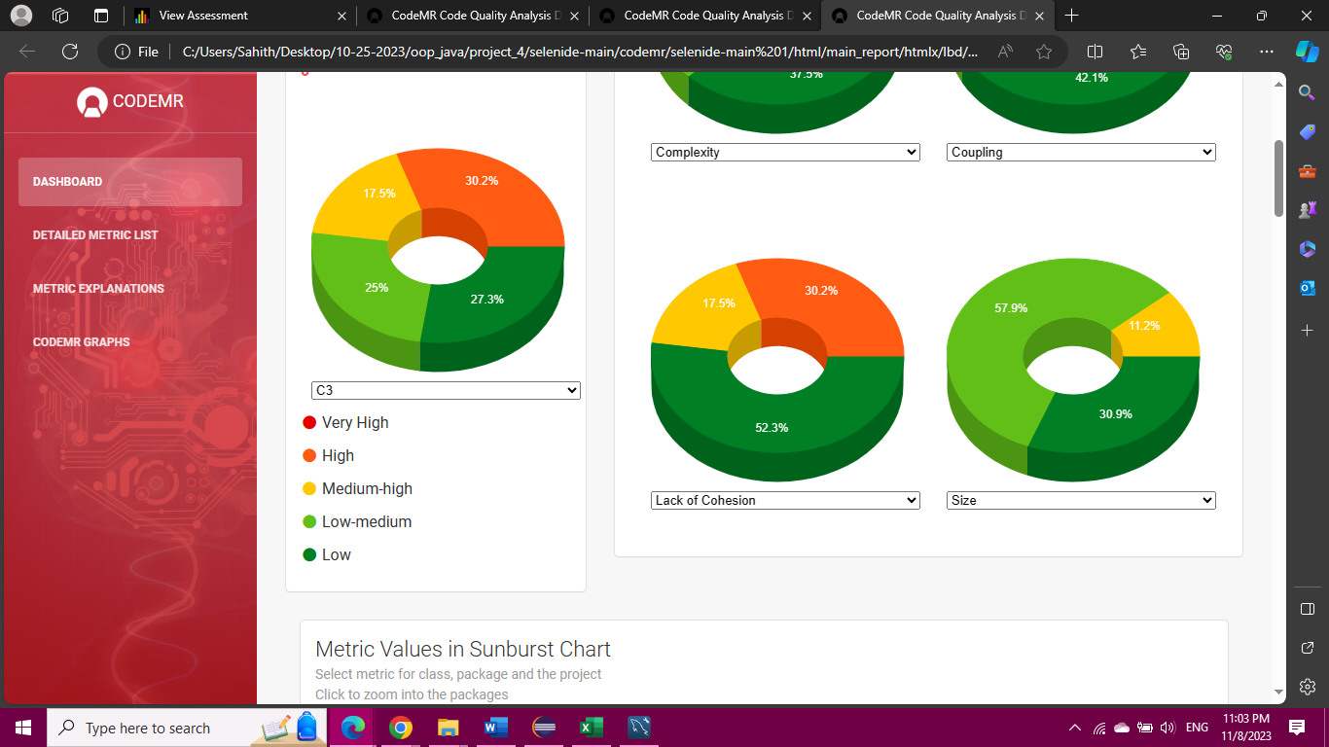

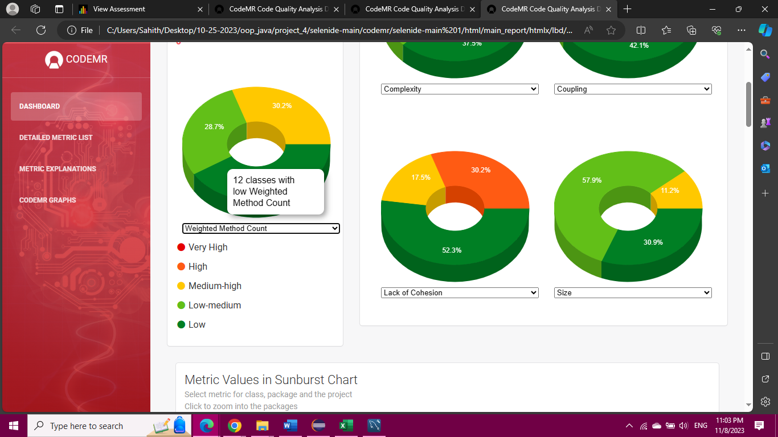

**Reactor-netty**

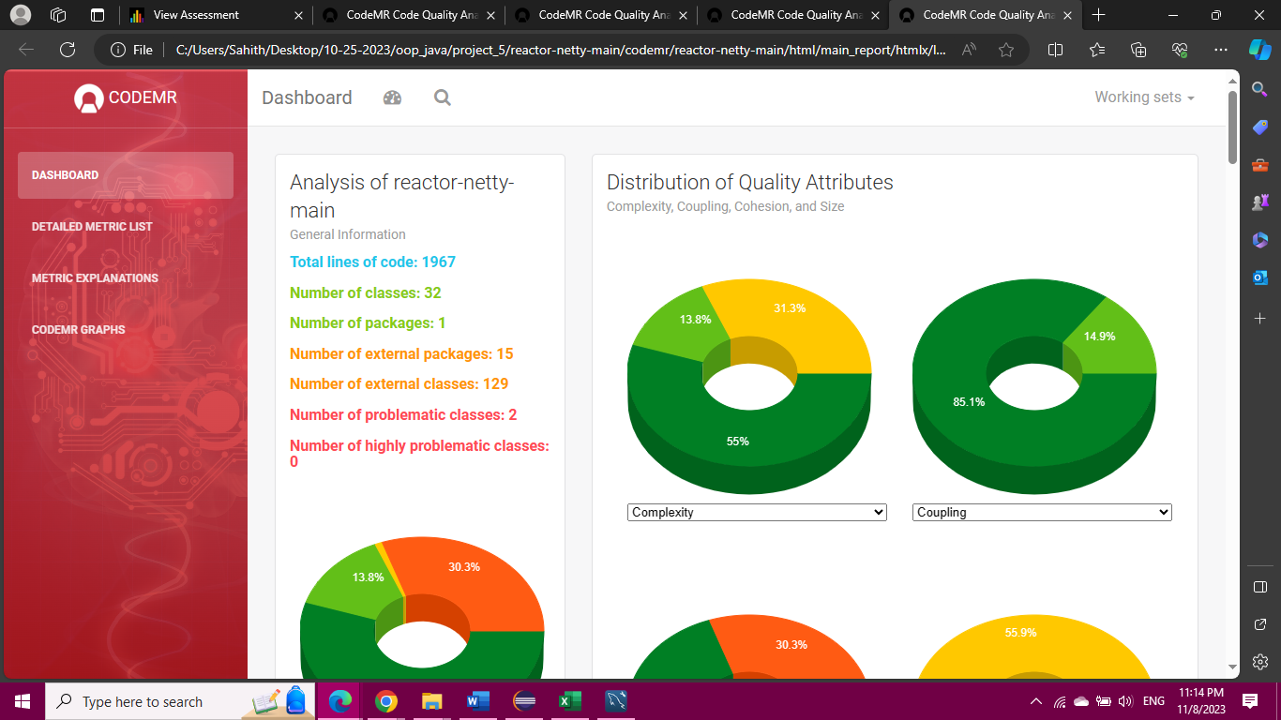

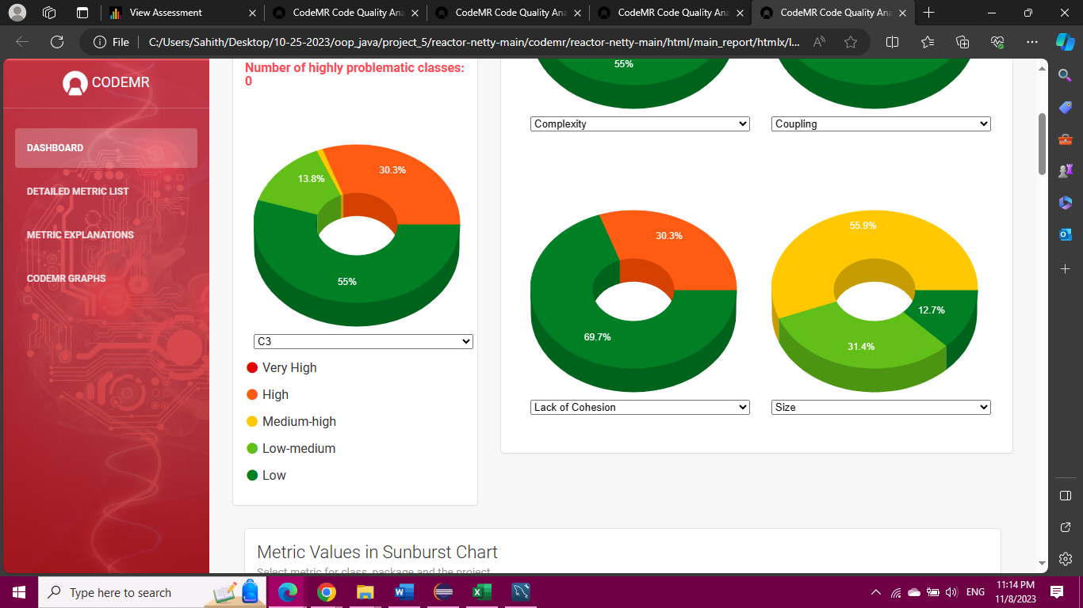

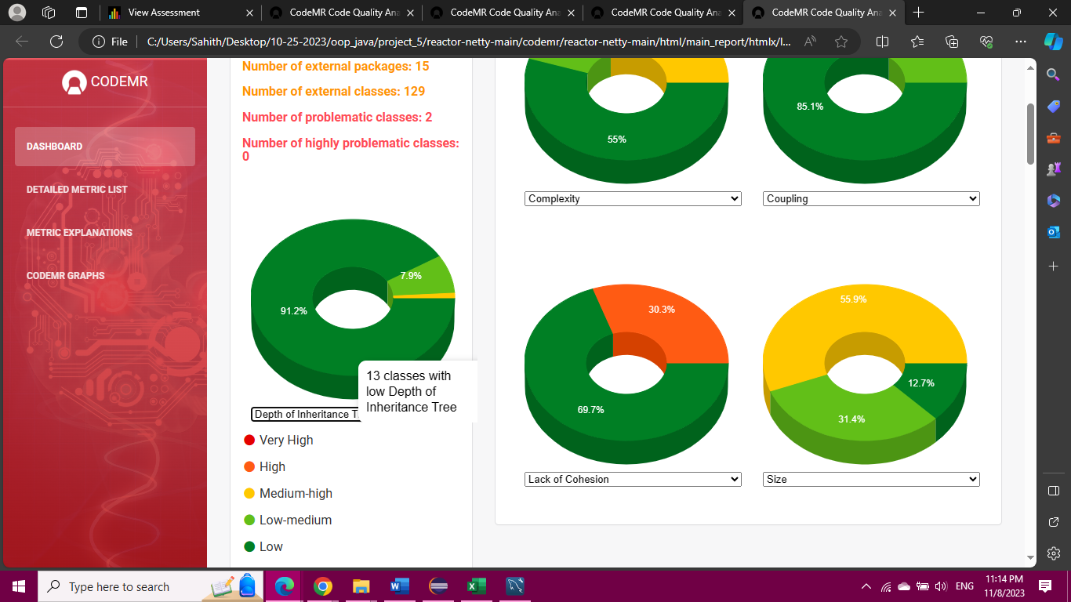

**Conclusions**

Based on the results of CK Metrics Suite of Spring Boot Applications

The matrix of software metrics offers valuable insights into various aspects of software design and complexity. Let's analyse how these metrics can influence the effect of class size on software maintainability:

Weighted Methods per Class (WMC):

Influence on Maintainability: Classes with a high WMC may require more effort to implement and test. If a class has too many methods with high complexity, it could potentially lead to decreased maintainability. Developers may find it harder to understand, modify, and debug such classes.

Depth of Inheritance Tree (DIT):

Influence on Maintainability: A high DIT value indicates a deep inheritance hierarchy, which can increase the complexity of understanding and maintaining the code. Deep hierarchies may lead to more intricate relationships between classes, potentially making it more challenging to modify or extend the codebase.

Number of Children (NOC):

Influence on Maintainability: A high NOC value implies that a class has many immediate subclasses. While this can potentially enhance reuse and abstraction, it can also lead to increased complexity. If not managed properly, a high number of subclasses might make it more challenging to maintain and understand the relationships between classes.

Coupling Between Object Classes (CBO):

Influence on Maintainability: High coupling between classes can make the codebase more tightly integrated. This can increase the complexity of modifications, as changes in one class may have cascading effects on others. It's important to manage CBO to ensure changes are localized and don't lead to unintended consequences.

Response for a Class (RFC)

Influence on Maintainability: A high RFC indicates a class with a potentially large number of methods that could be executed in response to messages. This can increase the complexity of testing and understanding the behavior of the class. It's important to manage RFC to ensure that classes have a clear and well-defined purpose.

Lack of Cohesion in Methods (LCOM)

Influence on Maintainability: A high LCOM value indicates that methods in a class may not be closely related in terms of accessing instance variables. This can lead to lower cohesion and potentially make it harder to understand and maintain the class. It's generally desirable to have higher cohesion for better maintainability.

Larger classes, as indicated by higher values in the above metrics, can potentially lead to decreased software maintainability if not managed carefully.

Properly managing the metrics like WMC, DIT, NOC, CBO, RFC, and LCOM is crucial. For example, ensuring that classes have a reasonable number of methods, managing inheritance depth, minimizing coupling, and maintaining high cohesion can all contribute to improved maintainability, even in the presence of larger classes.

It's important to strike a balance between the benefits of abstraction and reuse (which can come with larger classes) and the potential complexity that may arise from larger class sizes. This balance is crucial for creating maintainable software systems.

**Reference**

Yuniasri, D., Rochimah, S., & Raharjo, A. B. (2020, December). A Correlation Analysis Between ISO 25010 based Modularity and CK Metrics in Object-Oriented Software. In *2020 International Conference on Advanced Science and Engineering (ICOASE)* (pp. 1-6). IEEE.

Babu, G. V. R., Sailaja, P. D., & Srichandana, G. (2020). Common fixed points via Ck-class functions in S-metric spaces, J. *Fixed Point Theory*, *2020*, 22.